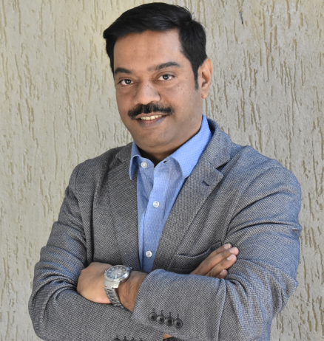

**BFC PUBLICATIONS PVT. LTD.**

**Personal Details**

|  |  |
| --- | --- |
| **Author Name** | Dr. Ravindra Dey |
| **Father Name** | Ashit Dey |
| **Date of Birth** | 15th January, 1974 |
| **Contact No** | 9820306565 |
| **Alternate contact no.** | 9820446619 |
| **e-mail ID** | ravindra.dey@gmail.com |
| **Nominee Name** | Mrs. Sumana Dey |
| **Correspondence Address :**  **Landmark**  **City**  **State**  **Pin Code**  **Country** | 802-803, Sunrise Point,  Neptune Living Point,  LBS Marg, Bhandup West  Near Mangatram Petrol Pump  Mumbai  Maharashtra  400078  INDIA |

**BANK DETAILS**

|  |  |
| --- | --- |
| **Account holder’s name** | Ravindra Dey |
| **Account No.** | S. B. A/c. No.  03981140001485 |
| **Bank Name** | HDFC Bank |
| **Branch** | Malad East |
| **IFSC Code** | HDFC0000398 |
| **Pan No.** | ABQPD9060N |

***(Note - *please enclose a photograph of cancelled cheque & PAN Card)***

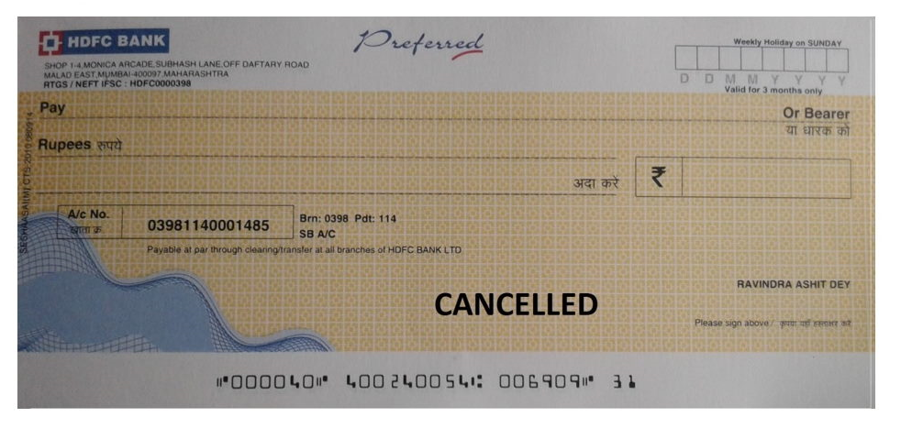

# 

# Book Details

|  |  |
| --- | --- |
| **Book Title** | **Path to Coaching**  A Handbook for Exploring Self and Others |
| **How would you like your name to appear on book?** | Dr. Ravindra Dey |
| **Manuscript Language** | English |
| **Book Genre** | Non-Fiction |
| **Number of images (If any)** | Will send the Draft |
| **Manuscript Status (Completed/Proof Read)** | No |
| **Book Size \*** | 5” x 8” |

**Standard Sizes:-**

* 5"x8"
* 6"x9"
* 8.5"x11"

**Cover details**

|  |
| --- |
| **Synopsis** - a**bout 500 words (to enable the cover designer to understand the theme of the book and would not be printed on the book)**  Coaching in itself is a process that can help you shape yourself. However, it deals with overlapping themes such as self-development, personal growth, introspection, etc. they are different in their approaches. Normally people feel that a coach is needed only when conditions/situations get worse. However, what would a person do when they need basic guidance to find out a way for their problems?  The coaching pathway can be the answer to this question. It is a kind of self-help book which could help people to find a direction when they face any roadblock. This book covers different aspects of coaching i.e., Self-Coaching, Physical wellness coaching, Emotional Intelligence Coaching, Parenting Coaching, Career Coaching, Sports Coaching, and Executive Coaching. This book helps the reader to identify the different areas of coaching and help them to understand and being able to analyze which area the reader needs to focus on to get clarity in their lives. |
| **Blurb - about the book** **(a short description of the book to be printed on the back of the cover.)**  Our lives are the result of our decisions, some that we make, some that are made for us. Often, it is experienced that we are faced with difficult situations that push us out of our comfort zone. At that time a path towards guidance is all that we need. This book will help in understanding the importance of a coach in one’s life. It mainly highlights various problems an individual faces in their lives.  If you are new to coaching this book would help you to kickstart your coaching business. Whereas if you are a person who needs coaching you would be able to gauge what to expect from the coach and how coaching works wonders. But always remember that coaching isn’t a job, it’s a mission that needs continuous dedication and practice.  I can hopefully say that by the end of this book one of the two things may happen to you i.e., either you would transform your life or you would help someone’s life to transform. |
| **Author Bio - about 200 words (a short description about you which will be printed on the back cover of the book.)**  Dr. Ravindra Dey is an award-winning Professor, Trainer, Licensed NLP practitioner and Executive Coach in India. He has so far trained thousands of participants in areas of behavioural science, organizational behaviour, organizational development, general management and leadership. He is well-known to bring a change in an individual and in an organization with simplicity and authenticity. His coaching, teaching, consulting and writing inspires people to develop and change and helps an individual to be the beaming light to unleash the inner self.  To learn more or to get in touch with Dr. Ravindra Dey, visit:  Ravindradey.com |